EE 463

STATIC POWER CONVERSION I

TERM PROJECT – SIMULATION REPORT

DC MOTOR DRIVE



**MIDDLE EAST TECHNICAL UNIVERSITY**

**DEPARTMENT OF ELECTRICAL AND ELECTRONICS ENGINEERING**

Metehan Küçükler 2305068

## INTRODUCTION

In this project, the aim is running and controlling a DC Machine with AC supplied circuitry. While designing the circuitry, it gives an opportunity of gathering experience about use of various power electronics component, datasheet reading and understanding, and basic PCB layout design. In this report, comparison of possible topologies is discussed, and initial design of the system analyzed. Lastly, possible fixes, and ideas to improve the design are mentioned.

### Comparison of Different Topologies

Possible topologies that can fulfill the project requirement can be these: Half-Full Controlled Bridge Rectifier with Thyristors and Buck Converter, Full Bridge Rectifier and Buck Converter with Diodes, and Dimmer Circuit with high RC filter.

Thyristor Rectifiers are good for high voltage and current applications. They have slightly less losses when compared with diodes. Also, they can make possible phase controlling of the circuitry. However, for each thyristor a control signal is needed which makes the circuit complicated.

Dimmer Circuit are easier than the thyristors for controlling the output voltage level with AC supply and TRIAC. Also, usage of TRIACS can make the four-quadrant operation possible. However, it is mostly utilized in AC applications. Filtering it requires high RC filter which requires more expensive and bigger components.

Diode Rectifiers are easy to construct among these topologies. This topology lacks the controlling part. With the help of the buck converter output voltage can be controlled.

Thus, I have chosen the Full Bridge Diode Rectifier and Buck Converter topology since it does not need complicated control and cheaper than the other topologies. Presence of a large inductor in DC Machine makes the filtering section of the Buck converter easier.

### Theoretical Calculations

As a requirement and limit, VOUT must be maximum 180V. Also, to operate the switch component of the buck converter, duty cycle of the PWM signal is limited between 0.1 and 0.9. Buck converter has input – output voltage relation as $V_{O}=D*V_{in}$, where D is the duty cycle between 0 and 1.

Thus, to get 180V output with highest duty cycle needed input for Buck converter is 180/0.9 = 200V. Additionally, full bridge rectifier gives the output voltage as 1.35 times input line-to-line voltage, rms which results in 200/1.35 = 148V. So, I decided to give input as 160V line-to-line rms voltage which gives some spaces for losses.

To select the buck converter components, I have simulated circuit with an inductor and without an inductor connected to switch and diode of the buck converter. Since DC Machine has a large inductor, it can keep its current almost constant with low ripple. However, when there is no filter inductor, capacitor used in buck converter drains too much ripple current at the closing instant of the switch which can damage itself and other components easily. On the other hand, choosing a proper filter inductor is difficult because keeping the buck converter in continuous conduction mode, CCM, requires high inductance value. At those values, finding an inductor with rated current around 20A is difficult, furthermore, after some research, I see there are no such inductors on the market. Mentioned calculations are below:

$$I_{LB,max}=\frac{V_{d}}{8*L*f_{s}}=\frac{160*1.35}{8*12.5*{10}^{-3}*f_{s}}$$

Equation above gives maximum inductor current to stay in the CCM as 2.16A when the switching frequency is selected as 1000Hz. There is nothing problematic at this calculation. However, when same calculation is done for filter inductor it results as 397A for 68µH inductance and 1000Hz switching frequency which is too higher for a small circuitry. Then I came the solution with increasing the switching frequency to 100 kHz which gives the result as 3.97A. As another solution, a zero-crossing control may be utilized for PWM control of switch, however, attempts for that design is failed for me.

$$Δi_{L}= \frac{V_{o}*(1-D)}{L*f_{s}}$$

Current ripple on a specific inductor can be calculated with equation above. It gives the maximum ripple current value when the duty cycle is 0.5. For armature inductor, current ripple is calculated as 0.04A when switching frequency is 100 kHz. On the other hand, current ripple of the filter inductor is 7.35A. Actually, it makes the current values of it between around 25-10A. However, in the simulations it seems these values are not applied well. I observed higher current ripples on filter inductor.

$$\frac{ΔV_{o}}{V_{o}}= \frac{1-D}{8*f_{s}^{2}*L*C}$$

Above equation gives the ratio of output current to its ripple value. For 1% ripple, minimum capacitance of the capacitor is computed as 16.5 µF. However, similar to current ripple of the filter inductance, this value is observed higher in simulation.

In the project requirements, it is said that the circuitry must be capable of supplying 2kW with maximum of 180V output which results with around 12A armature current to give some space to losses. Also, If it is assumed that the whole circuit is operating with 80% efficiency, it needs to drain 15A from the grid. When the current ripples are taken into consideration this value peaks to 25A.

### Simulation Results

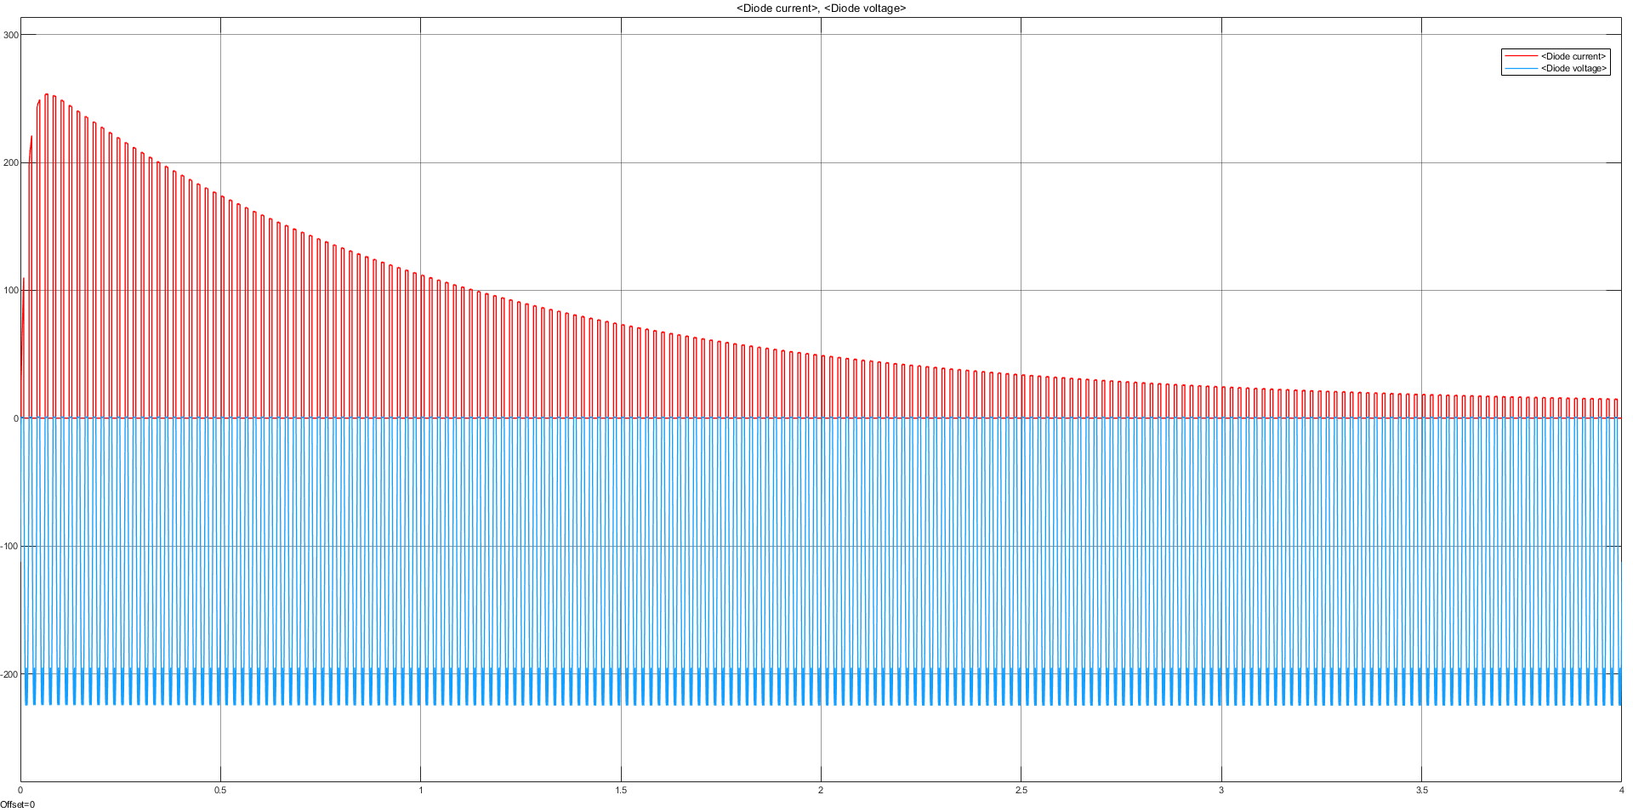

Figure 1: Diode current and voltage.

In the Figure 1, it can be seen that there are inrush current because of the DC Machine. Since when machine is stationary it has no back-emf, the current drained from armature terminals is too high. To prevent from this problem a soft starter must be utilized. Also, it cannot be fully prevented. Thus, diodes must be selected accordingly.

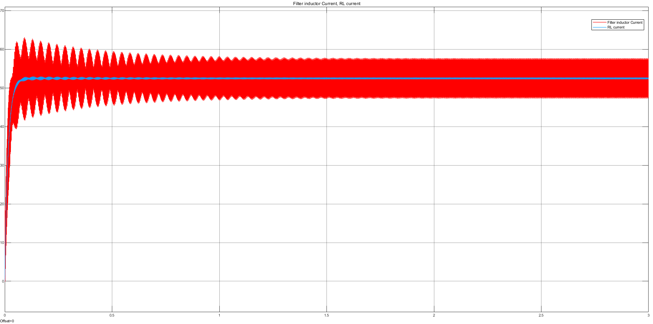

Figure 2: Currents on inductors with 0.2 Duty Cycle.

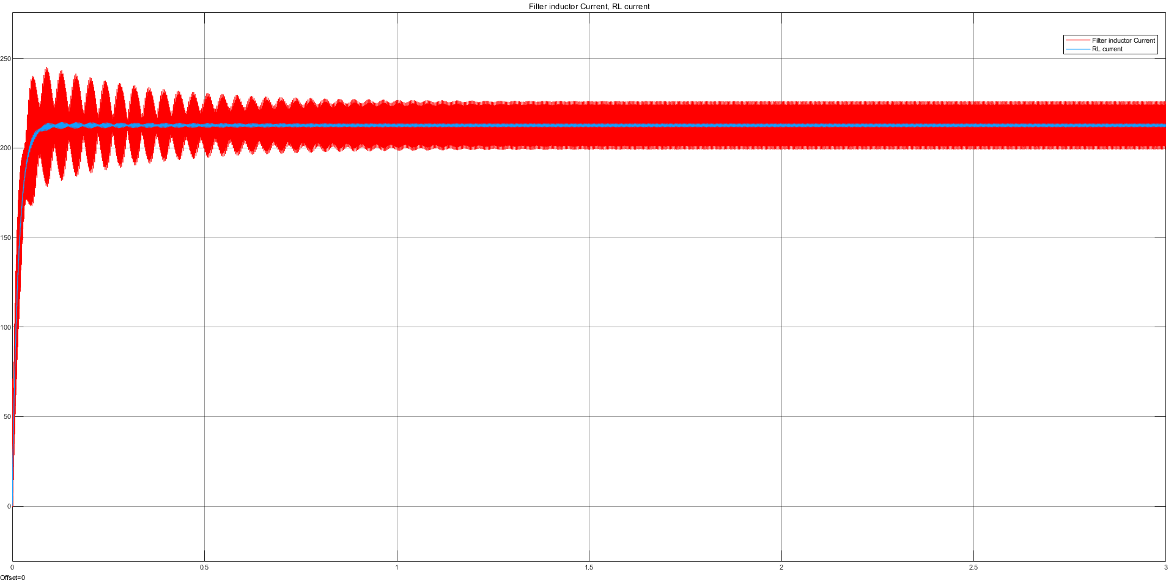

Figure 3: Currents on inductors with 0.8 Duty cycle.

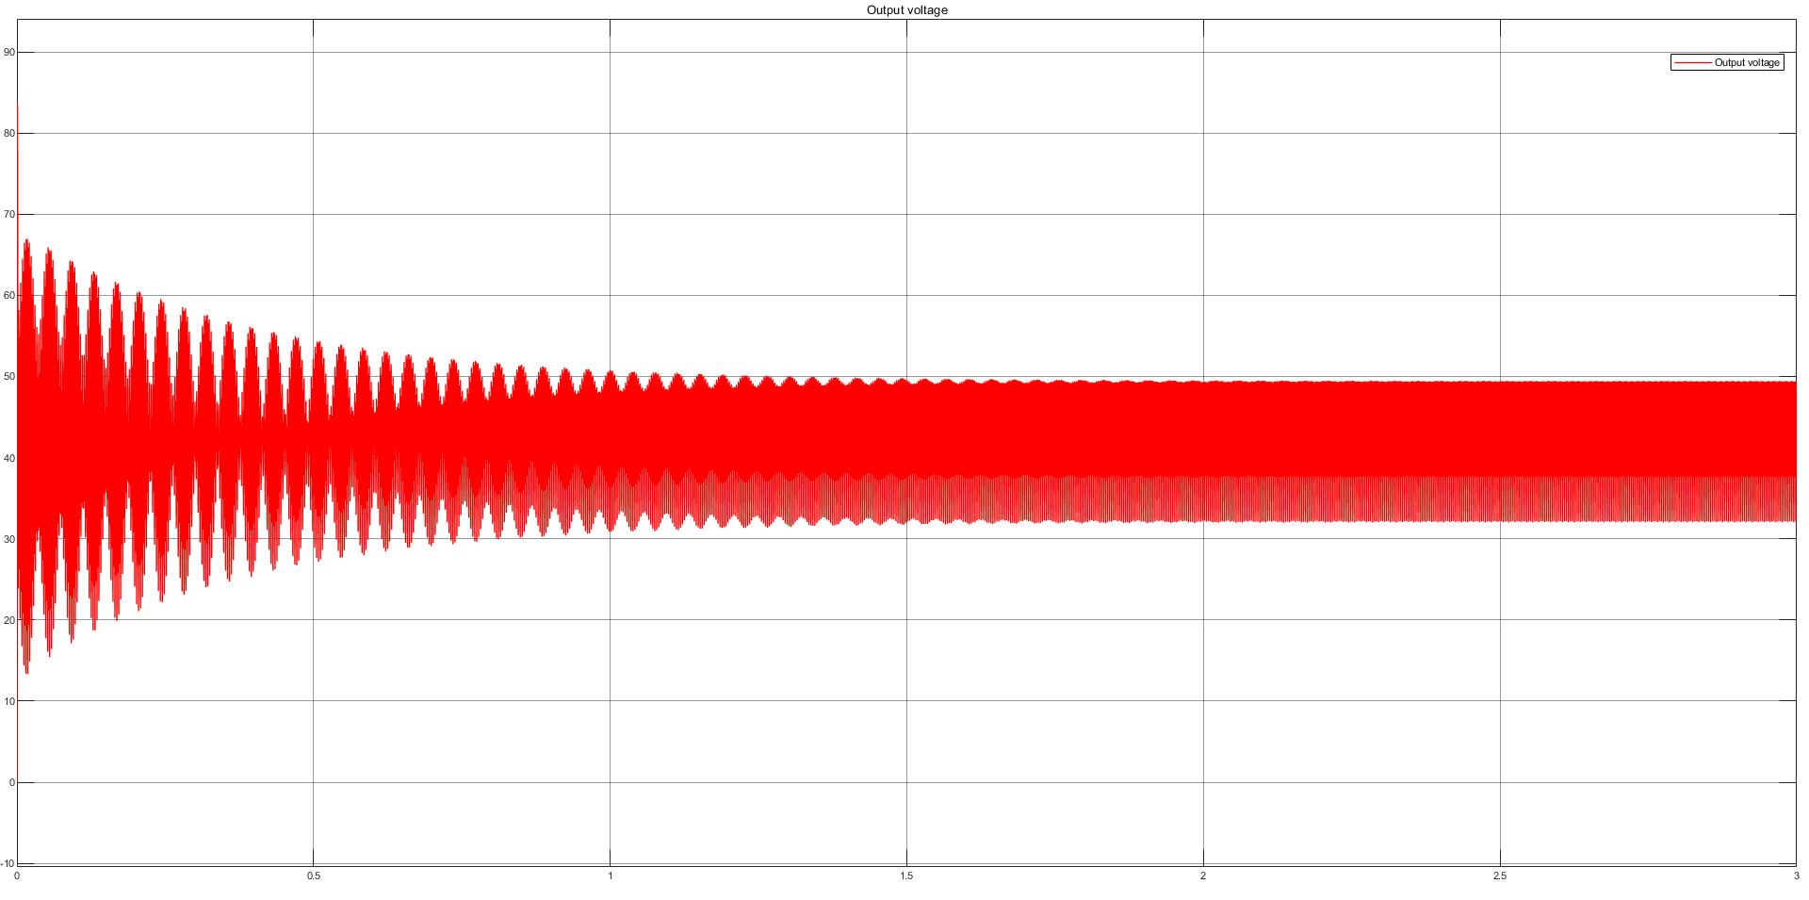

Figure 4: Output voltage with 0.2 duty cycle.

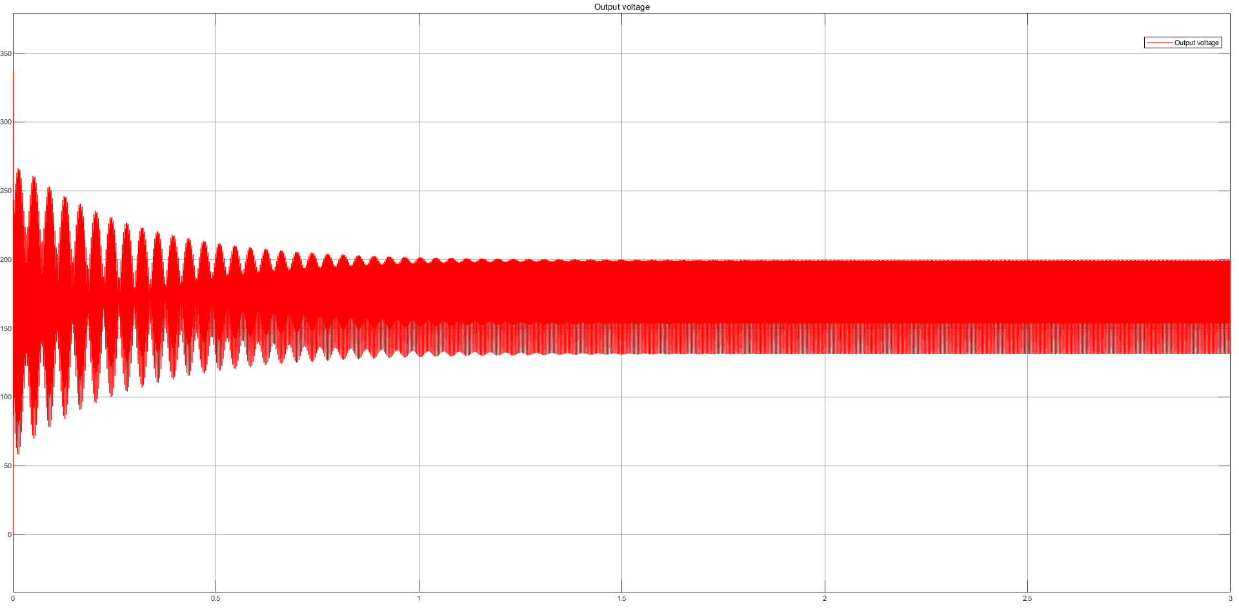

Figure 5: Output voltage with 0.8 duty cycle.

Switching frequency is determined as 100 kHz above, however, simulating the circuit with that value lasts too long. Thus, figures above are taken from 10 kHz switching frequency.

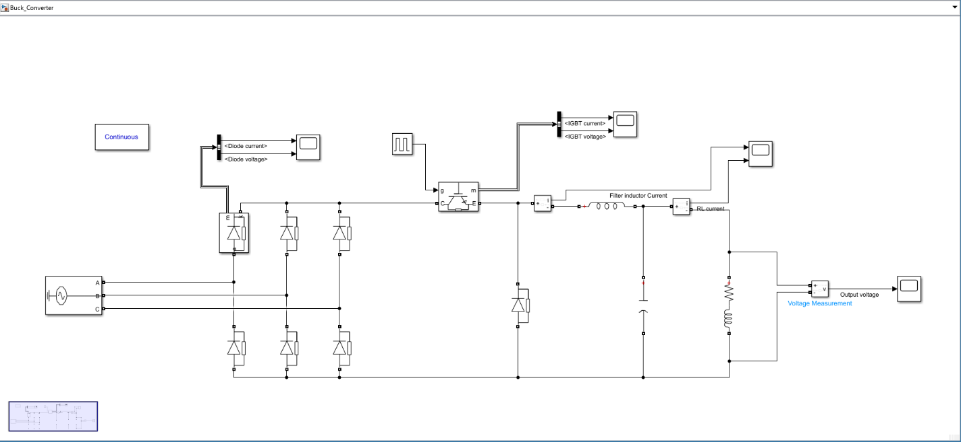

Figure 6: Test schematic with RL load.

Since I cannot obtain proper results with the DC Machine, I have simulated the buck converter operation with different duty cycles with RL load which has identical values with armature resistance and inductance. I increased the filter inductance to 680µH so that it gives similar result for current ripple. However, it seems it is not identical with the theoretical value.

### Component Selection

I have selected diodes with respect to theoretical calculations. Rated output current of the system is selected as 15A. With current peaks, there should be maximum of 25A peak drained from the source side. Thus, diodes and IGBT must have higher than 25A rated current. To prevent from the voltage ripples their rated voltage should higher than 400V.

Filter inductor is selected as 68µH with peak rated current of 25A. However, there no inductance with those values in the market. On the other hand, I have found some inductors with 1mH with rated current 3A which are named as common mode chokes. When I research these types of inductors, although not sure, I think there are no difference in this type.

The required output voltage is 180V. Thus, filter capacitor at the buck converter must selected with rated voltage as this value. Output voltage ripple calculations gives the minimum of 16.5µF capacitance, however, as it can be seen in Figures 4 and 5, even with 100µF capacitance output voltage have high ripples. Thus, I must have use higher capacitance values to filter the output voltage better.

As a controller I choose Raspberry Pi Pico which has 125MHz ARM core which is enough for the switching frequency. Additionally, it has 8 PWM channel, general purpose input/output, and 3 ADC, analog-to-digital converter, pin which can be used for closed-loop controlling of the buck converter and soft starting operation. Also to drive the gates of the IGBT, since current output of the controllers’ pins is not enough, an optocoupler must be used.

### Comments & Conclusion

To sum up, this project required many simulations to decide the rated values of components used. In the simulations, since the non-idealities in the real environment cannot be determined, the results may be not accurate. To properly test and determine the components, these tests must be done in laboratories.

The circuitry has issues about current ripples, and uncontrolled buck converter. To resolve these problems, closed-loop feedback control for current or voltage at the output may be utilized. This control can be done with comparator or op-amp circuitries by feeding that information to Raspberry Pi Pico and analyzing that information with specific algorithms.

After simulations and component selections are done, creating a schematic and PCB layout in KiCad left. To create proper PCB layout, EMI, ESD problems must be taken into consideration. Also, thermal analysis must be done.